AI could make it less necessary to learn foreign languages

人工智能可能使学习外语的必要性降低

## That is good news for travellers, bad news for soulful connection

这对旅行者来说是好消息，但是却不利于心灵的链接

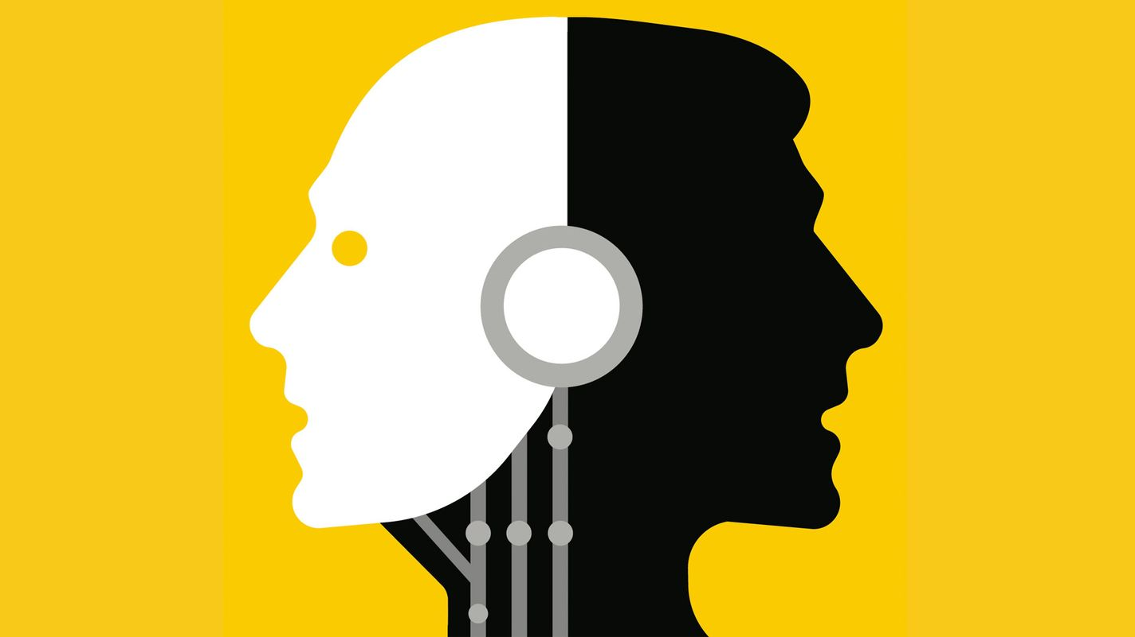

image: nick lowndes

On holiday, many will find themselves in places where they do not speak the language. Once upon a time, they might have carried a phrasebook. The [rise of English](https://www.economist.com/culture/2023/05/25/as-it-spreads-across-the-world-who-owns-english) has made that less necessary. But most people—at least seven of the world’s eight billion—still do not speak English. That leaves options like pantomime, a willingness to be surprised by what arrives at dinner—or, increasingly, [technology](https://www.economist.com/culture/2022/11/30/the-translator-of-the-future-is-a-human-machine-hybrid).

More and more people are using simple, free tools, not only to decode text but also to speak. With these apps’ conversation mode, you talk into a phone and a spoken translation is heard moments later; the app can also listen for another language and produce a translation in yours.

在度假时，很多人会发现自己身处不会说当地语言的地方。过去，他们可能会携带一本短语手册。然而，英语的普及使得这种需求变得不那么迫切。但是，仍然有大多数人（世界上80亿人口中至少有七分之六）不会说英语。这就只能选择哑剧表演、愿意对晚餐的内容产生惊喜，或者越来越多地依赖技术解决语言障碍。

越来越多的人开始使用简单且免费的工具，不仅用于解码文本，还可以进行语音交流。通过这些应用程序的对话模式，您只需对着手机说话，片刻之后就能听到口语翻译；该应用程序还可以倾听其他语言并将其翻译成您的语言。

You may still get a surprise or two. Google Translate may be the best-known name in machine translation, but it often blunders. Take “my wife is gluten-free,” the kind of thing you might say at a restaurant abroad. In French or Italian, Google Translate renders this as “my wife is without gluten”—true to the words rather than the meaning. DeepL, a rival, does better, offering various options, most of them along the correct lines.

The best tool may not be a translation app at all. Though not marketed for the purpose, Chatgpt, a [generative ai system](https://www.economist.com/business/2023/08/13/ai-is-setting-off-a-great-scramble-for-data) that churns out prose according to users’ prompts, is [multilingual](https://www.economist.com/culture/2023/03/29/chatgpt-is-a-marvel-of-multilingualism). Rather than entering an exact text to translate, users can tell Chatgpt to “write a message in Spanish to a waiter that my wife and I would like the tasting menu, but that she is gluten-free, so we would like substitutions for anything that has gluten.” And out pops a perfect paragraph, including the way Spanish-speakers actually say “my wife is gluten-free”: *mi esposa es celíaca*. It is a paraphrase rather than a translation, more like having a native-speaking dinner companion than an automated interpreter.

您可能仍然会遇到一两个意外。谷歌翻译可能是机器翻译中最知名的名字，但它经常犯错。以“我的妻子不能吃麸质食品”为例，这是您在国外餐厅可能会说的话。在法语或意大利语中，谷歌翻译将其翻译为“我的妻子没有麸质”，更注重文字而非意义。然而，DeepL作为竞争对手，做得更好，提供了各种选项，其中大部分都沿着正确的方向。

而实际上，最好的工具可能并不是一个翻译应用程序。尽管Chatgpt并非专门为此推出，但它是一个生成式人工智能系统，根据用户提示生成散文，具备多语言能力。用户无需输入要翻译的准确文本，而是可以告诉Chatgpt：“用西班牙语给一名侍者写一条消息，告诉他我和我的妻子想要品尝菜单，但她不能吃麸质食品，所以我们需要替换任何含麸质成分的食物。”随后，Chatgpt会生成一段完美的段落，其中包含西班牙语使用者实际上说的“我的妻子不能吃麸质食品”：mi esposa es celíaca。这更像是与一位母语为西班牙语的用餐伴侣交谈，而不是一个自动化的口译工具。

Travel has long been a motivator for study—unless people start to feel ai tools offer a good-enough service. Some are concerned that apps are turning language acquisition into a dwindling pursuit. [Douglas Hofstadter](https://www.economist.com/by-invitation/2022/09/02/artificial-neural-networks-today-are-not-conscious-according-to-douglas-hofstadter), a polyglot and polymath writer, has argued that something profound will vanish when people talk through machines. He describes giving a halting, difficult speech in Mandarin, which required a lot of work but offered a sense of accomplishment at the end. Who would boast of taking a helicopter to the top of Mount Everest?

Others are less worried. Most people do not move abroad or have the kind of sustained contact with a foreign culture that requires them to put in the work to become fluent. Nor do most people learn languages for the purpose of humanising themselves or training their brains. On their holiday, they just want a beer and the spaghetti carbonara without incident (and sometimes without gluten).

旅行一直以来都是学习的动力，但如果人们开始觉得人工智能工具提供的服务已经足够好了，那么情况可能会发生变化。有人担心应用程序正在使语言学习变得越来越不重要。多语者和博学的作家道格拉斯·霍夫斯塔德认为，当人们通过机器进行交流时，会有一种深刻的东西消失。他描述了自己吃力地用普通话发表演讲的经历，尽管过程困难重重，但最终带来了一种成就感。毕竟，谁会吹嘘自己乘坐直升机登上珠穆朗玛峰呢？

然而，其他人对此并不太担心。大多数人并不会移居国外，也没有与外国文化进行持续接触的机会，这就不需要他们付出大量努力来掌握流利的语言。而且，大多数人学习语言并非为了增加人性化或训练大脑的目的。在度假期间，他们只是想要轻松地享受一杯啤酒和意大利炭烤培根意面，没有任何意外发生（有时还要无麸质）

As ai translation becomes an even more popular labour-saving tool, people will split into two groups. There will be those who want to stretch their minds, immerse themselves in other cultures or force their thinking into new pathways. This lot will still take on language study, often aided by technology. Others will look at learning a new language with a mix of admiration and puzzlement, as they might with extreme endurance sports: “Good for you, if that’s your thing, but a bit painful for my taste.”

This is largely an Anglophone problem, since native English-speakers miss out on the benefits of language-learning most acutely. In many countries, including Britain and America, schools’ and universities’ foreign-language departments have been closing. (The British government recently devoted a modest fund to trying to get more secondary-school pupils to study foreign languages.) In the rest of the rich world, there is one thriving language that people still study: English. And in poorer countries, many people are multilingual as a matter of course; Africans and Indians learn languages because they are surrounded by them.

随着人工智能翻译越来越成为一种受欢迎的省时工具，人们将分为两个群体。一方面，有些人希望拓展思维，沉浸于其他文化，或通过学习语言来开拓新的思维路径。这些人仍会选择学习语言，通常借助技术的帮助。另一方面，有些人对学习一门新语言充满了欣赏和困惑，就像对待极限耐力运动一样：“如果这是你的兴趣，那太棒了，但对我来说有点痛苦。”

这主要是一个英语使用者面临的问题，因为以英语为母语的人最为明显地错过了语言学习的好处。在许多国家，包括英国和美国，学校和大学的外语系部门已经关闭。（英国政府最近投入了一笔适度的资金，试图让更多中学生学习外语。）而在其他发达国家，人们仍然积极学习一种语言：英语。而在较贫穷的国家，许多人自然而然地会掌握多种语言，因为他们身处的环境中有多种语言存在。

But a focus on the learner alone misses the fundamentally social nature of language. It is a bit like analysing the benefits of close relationships to heart-health but overlooking the inherent value of those bonds themselves. When you try to ask directions in broken Japanese or mangle a joke in halting German, you are making direct contact with someone. And when you speak a language well enough to tell a story with perfect timing or put subtle shading on an argument, that connection is more profound still. The best relationships do not require an intermediary. ■

然而，仅仅关注学习者本身会忽视语言的根本社交性质。这有点像分析亲密关系对心脏健康的好处，但却忽略了这些纽带本身的内在价值。当你试着用蹩脚的日语问路或者用支吾的德语说笑话时，你直接与他人进行了接触。当你能够流利地讲述故事并恰到好处地表达论点时，这种联系更加深刻。最好的关系不需要借助中介 **Read more from Johnson, our columnist on language:**[*In northern Europe, a backlash against English is under way*](https://www.economist.com/culture/2023/07/20/ai-is-making-it-possible-to-clone-voices)*(Aug 4th)*[*AI is making it possible to clone voices*](https://www.economist.com/culture/2023/07/20/ai-is-making-it-possible-to-clone-voices)*(Jul 20th)*[*Talking about AI in human terms is natural—but wrong*](https://www.economist.com/culture/2023/06/22/talking-about-ai-in-human-terms-is-natural-but-wrong)*(Jun 22nd)*

*For more on the latest books, films, tv shows, albums and controversies, sign up to*[*Plot Twist*](https://www.economist.com/culture/2022/11/23/introducing-plot-twist-our-new-culture-newsletter)*, our weekly subscriber-only newsletter*